**南京航空航天大学金城学院**

**毕业设计（论文）外文文献翻译**

|  |  |  |  |
| --- | --- | --- | --- |
| **学 院** | 信息工程 | | |
| **专 业** | 计算机科学与技术 | | |
| **学生姓名** | 陈家盛 | **学号** | 2016022232 |
| **指导教师** | 郭慧敏 | **职称** | 副教授 |

二〇二〇年 三 月

2019 International Conference on Computer Information Analytics and Intelligent Systems (CIAIS 2019)

**The Design of Campus Lost and Found Platform Based on Digital Map Data**

Luquan Jiang1,a, Hanyu Mao2,b and Zhiliang Kang2,c,*

1Ya’an Polytechnic College Ya’an, Sichuan Province, China

2School of Mechatronical Engineering, Sichuan Agricultural University, Ya’an, Sichuan Province,

China

a314550502@qq.com;b1271004623@qq.com; ckangzhiliang96@163.com

*Corresponding author

**Keywords:**Lost and found; Map data; Map API; Campus network platform; Android

**Abstract:** Aiming at the inefficiency of the existing lost and found system on campus and the inability to meet people's needs, this paper proposes a platform for online lost and found network based on digital map data. The platform uses API of online map data service to process lost and found information, and adds a push and reward module to increase people's enthusiasm for returning the picked items. After testing, the platform is capable of the functions of users’ registration and logging in, releasing the loss of material information ,as well as pushing lost and found messages automatically and so on. According to the statistics, the application of digital map data in lost and found platform has improved the success rate of lost and found.

**Introduction**

In the university campus, there are always some students inadvertently lost something, such as campus card, wallet, mobile phone and other electronic valuables.The loss of these items, more or less will make students feel heavy, to leave a shadow of the beautiful university life.Regardless of those who find it as their own exception, there are still a large number of students are willing to return the lost property to its owner.However, according to the current situation, students usually release information through QQ group, QQ space, post bar and other platforms when they encounter lost or found other people's articles.However, according to the current situation, students usually release information through QQ group, QQ space, post bar and other platforms when they encounter lost or found other people's articles.[1]Nevertheless, these platforms have significant limitations.Despite the existence of the "Six Degrees of Separation theory", the reality is that a lot of information simply can not successfully cross the right destination to achieve its value, more is as junk information end up with nothing definite.[1]

In order to set up a convenient and efficient lost and found network platform for those who have found and lost things to upload their information and publish their information.This article designs and implements a campus lost and found network platform based on map data.That is to take Android as the development platform, access to the existing map API,organize users' published information, and push messages to users in a certain area near the location of lost property.And add reward mechanism, by the platform and the owner of the user who returned the lost property for a certain reward.[2]This platform can improve the low efficiency and poor dissemination of the original lost and found mode, and at the same time improve the initiative of the owners to return the lost and found, and promote the standardized development of the school's lost and found system.

**Analysis and Design the Platform**

This platform is based on the server database of Android system. Users can publish and obtain the lost and found information on the platform through the Android mobile client anytime and anywhere. Compared with the traditional mode, it is more flexible and practical.

According to the actual needs of campus lost and found, according to the function, the whole platform is mainly divided into six functional modules: registration/login system, lost and found release system, lost and found release system, information acquisition system, online chat system and background management system. Each functional module is composed of several sub-modules.

**Software Desk Implementation**

The campus lost and found platform based on map data adopts the development form of Android APP, and uses JAVA HTML5 CSS3 and other programming language development platform, which is applicable to Android4.4 and above. [3-5]

UI Design and Implementation. User interface is the user to use this platform portal, should bring a good user experience for the user. So, the UI design must be beautiful and simple operation is simple to understand. [6] The map data based on the development of the lost and found platform, through the Android Studio to write user interface as shown in figure 1. It is mainly including the login interface (a), home page (b), personal center page (c), publishing interface (d) and so on.

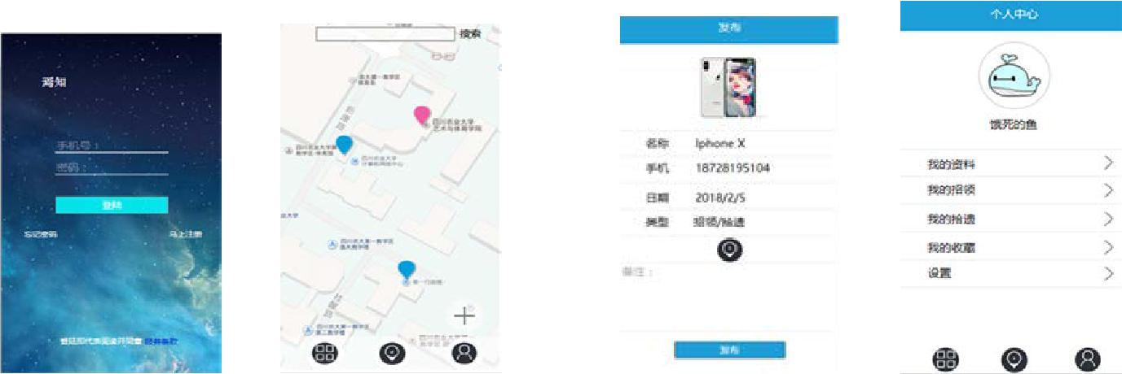

1. Login page （b） Home page （c） Personal center page（d）the published pages

**Fig.1 User interface**

Map Data Access Implementation. In order to realize map data access, this platform adopts the domestic relatively mature Baidu map API usage method referring to the development documents provided by Baidu map. This platform mainly uses two major services, namely, location service and map service.

The main steps to obtain location service include: a. open Android project, b. add SDK, c.

configure build gradle file, d. add AK, and e. add location permission.

Push Function Implementation. Push refers to the active message push of a software operator through a product or a third-party tool to a user's mobile device. [8] Users can see push messages on the mobile device's lock screen and notification bar, and click on the notification bar to evoke the app and go to the page. The QQ messages and WeChat messages that are seen on the lock screen interface are all in the rank of message push.

News push can be developed by itself, but the cost of such development is relatively high. Most mobile application developers choose to use third-party tools. The more common ones in China are: Xiaomi, Push, Union, Baidu, Tencent, Aurora, Huawei cloud push and so on.

The platform uses the third-party tool Tencent homing pigeons to implement the push function.

The push function implementation process is as follows [9]:

a. When the platform client app starts, it will start a pigeon main service, the pigeon main service is globally unique, and one device shares a pigeon main service;

b. The homing pigeon main service randomly starts a backup service in the application of the access pigeon, and the two services pull each other and are mutually backup;

c．The homing main service establishes a Socket long connection of the homing server and maintains a long connection through a heartbeat mechanism;

d. The client main service requests a token from the pigeon server through the Socket long connection request;

e. The homing pigeon server pushes the message to the client main service via the Socket long connection[10];

f. The main Service forwards the Push message to the client APP of the platform.

Database Implementation. The platform database is mainly used to store the basic information of the user and the information and location of the item. The basic information of the user mainly includes the user's mobile phone number, user name, password, and the like. The item information mainly includes the item name, lost/picked location, lost/picked time, returned status, and other descriptive information.

This platform uses Oracle database to store data and uses JDBC to connect to the database. [11,12] The database E-R diagram design of this system is shown in Figure 2. [13] In the lost and found

system, the owner, the lost object, the picker, and the pick-up are four entities, which themselves have multiple character attributes, which are respectively published relationships.

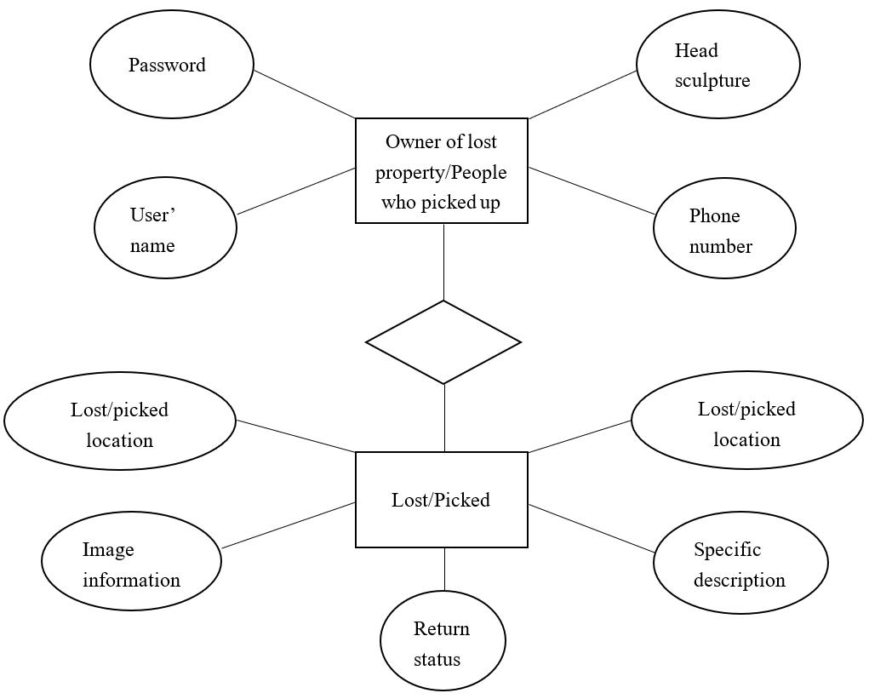

Fig.2 System overall E-R diagram

**System Test**

Function Test. Functional testing is to verify the various functions of the lost and found platform, according to the functional test cases, item by item test, to check whether the platform meets the design requirements. This article starts from the login APP to gradually test whether the requirements are completed, to determine whether the data is consistent and can be received and returned normally. For example: whether the user registration function is perfect, whether the lost and picked-up information can be released and shared after the registration is successful. Secondly, test the logic of the software, whether the page conversion is completed normally according to requirements, etc. For example, when clicking "Publish", the information will jump to the page where the information is presented. When the amount of information is large, the scroll bar works. Finally, test the software's flashback and system startup time and network request time. The following is an example of the registration/login function, as shown in Table 1.

**Table. 1 Login function tests**

|  |  |  |  |  |  |  |  |
| --- | --- | --- | --- | --- | --- | --- | --- |
| Project name | | Design and Implementation of Campus Lost and Found Platform Based on Map Data | | | | | |
| Test environment | |  |  | Android8.0.0 | |  |  |
| tester | |  |  | Tester | |  |  |
| Test module | |  |  | Registration/login function | | |  |
| Numbering | Scenes | Precondition | Test | Expected results |  | Test Results | Remarks |
|  |  |  | procedure |  |  |  |  |
| 1 | Initial page | Install APP | Click to | Present |  | Present | Unregistered |
|  | display | users | enter APP | registration/login |  | registration/login | users cannot |
|  |  |  |  | interface |  | interface | log in |
| 2 | Account | Install APP | Click to | Show input |  | Show input | The account |
|  | entry | users | enter an | account |  | account | number is 11 |
|  | verification |  | account |  |  |  | mobile phone |
|  |  |  |  |  |  |  | number |
| 3 | Account | Account | Click to | Show account |  | Show account | Enter the |
|  | fault | entered | enter your | verification |  | verification | account ID |
|  | tolerance |  | password | succeeded |  | succeeded | that does not |
|  | verification |  |  |  |  |  | exist X |
| 4 | Password | Account | Click to | Show input |  | Show input | The password |
|  | input | entered | enter your | password |  | password | is 8-13 letters |
|  |  |  | password |  |  |  | plus numbers |
| 5 | System | Account and | Click to | Display |  | Display | Get user |
|  | login | password | Login | homepage |  | homepage | location |
|  |  | have been |  |  |  |  | information |
| 7 | Password | Account and | Click to | Log in system |  | Log in system | Password |
|  | check | password | Login |  |  |  | verification |
|  |  | have been |  |  |  |  | did not |
|  |  | entered |  |  |  |  | successfully |
|  |  |  |  |  |  |  | display the |
|  |  |  |  |  |  |  | password error |

Performance Test. The goal of software performance testing is to verify whether the performance of software can meet the performance indicators when it is reused under normal environment and

system conditions, to find the shortcomings and defects of the system, and to repair them in time, so as to make the winding have better fluency and stability. [14] The system uses the built-in fluency test function in Android's developer mode to test the fluency of the system.

This system uses millet 5, click on more settings in Settings, enter the developer's option, you can see the "GPU rendering mode analysis" option. After opening, you can display the interface

response speed of the system by bar and line graphs, so as to observe the fluency of the system. [15] This curve shows that the system runs smoothly as long as it does not exceed the green line. As shown in Figure 3, open the GPU rendering pattern analysis diagram.

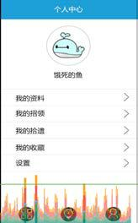 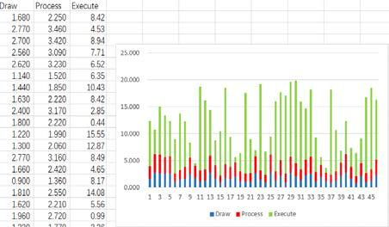

**Fig.3 Opens the GPU rendering pattern analysis diagram Fig. 4 System fluency**

Restart the lost and found APP application, start the application , slide the page accordinglu,enter the corresponding instructions under the command line, find the required fluency data, put it in the Excel table, and view its fluency in the form of its chart, as shown in Figure 4.

**Detaled Description**

Various embodiments of the present invention will be described in detail with reference to the drawings, where like reference numerals represent like parts and assemblies throughout the several views. Reference to various embodi ments does not limit the scope of the invention, which islimited only by the scope of the claims attached hereto. Addi tionally, any examples set forth in this specification are not intended to be limiting and merely set forth some of the many possible embodiments for the claimed invention. Among other things, the present invention may be embodied as meth ods or devices. Accordingly, the present invention may take the form of an entirely hardware embodiment, an entirely Software embodiment or an embodiment combining Software and hardware aspects. The following detailed description is, therefore, not to be taken in a limiting sense. Throughout the specification and claims, the following terms take the meanings explicitly associated herein, unless the context clearly dictates otherwise. The phrase “in one embodiment as used herein does not necessarily refer to the same embodiment, though it may. As used herein, the term “or is an inclusive'or' operator, and is equivalent to the term “and/or unless the context clearly dictates otherwise. The term “based, in part, on”, “based, at least in part, on', or “based on is not exclusive and allows for being based on additional factors not described, unless the context clearly dictates otherwise. In addition, throughout the specification, the meaning of “a,” “an and “the include plural references. The meaning of “in” includes “in” and “on.” Briefly stated, certain embodiments of the invention are related to a system and method for lost and found that includes enabling information about found objects to be stored in real time. The method further includes enabling adjustment of a field of view of an interactive map. The method further includes receiving a search input for search of a lost object. The method further includes performing a search for the lost object based on at least the stored informa tion about the found objects, the search input, and the field of view of the interactive map. The method further includes enabling results of the search to be overlaid on the interactive map.

**Illustrative Operating Environment**

FIG. 1 shows components of one embodiment of an envi ronment in which the invention may be practiced. Not all the components may be required to practice the invention, and variations in the arrangement and type of the components may be made without departing from the spirit or scope of the invention. As shown, system 100 of FIG. 1 includes local area networks (“LANs')/wide area networks (“WANs”)-(net work) 105, wireless network 110, client devices 101-104, service device 108, and nap server 107. One embodiment of a client device usable as one of client devices 101-104 is described in more detail below in conjunc tion with FIG. 2. Generally, however, client devices 102-104 may include virtually any mobile computing device capable of receiving and sending a message over a network, Such as wireless network 110, or the like. Such devices include por table devices such as, cellular telephones, Smartphones, dis play pagers, radio frequency (RF) devices, infrared (IR) devices, Personal Digital Assistants (PDAs), handheld com puters, laptop computers, wearable computers, tablet com puters, integrated devices combining one or more of the pre ceding devices, or the like. Client device 101 may include virtually any computing device that typically connects using a wired communications medium Such as personal comput ers, multiprocessor Systems, microprocessor-based or pro grammable consumer electronics, network PCs, or the like. In one embodiment, one or more of client devices 101-104 may also be configured to operate over a wired and/or a wireless network.

Client devices 101-104 typically range widely in terms of capabilities and features. For example, a cellphone may have a numeric keypad and a few lines of monochrome LCD display on which only text may be displayed. In another example, a web-enabled client device may have a touchsen sitive screen, a stylus, and several lines of color LCD display in which both text and graphics may be displayed. A web-enabled client device may include a browser appli cation that is configured to receive and to send web pages, web-based messages, or the like. The browser application may be configured to receive and display graphics, text, mul timedia, or the like, employing virtually any web-based lan guage, including a wireless application protocol messages (WAP), or the like. In one embodiment, the browser applica tion is enabled to employ Handheld Device Markup Lan guage (HDML), Wireless Markup Language (WML), WML Script, JavaScript, Standard Generalized Markup Language (SMGL), HyperTextMarkup Language (HTML), eXtensible Markup Language (XML), or the like, to display and send information.

Client devices 101-104 also may include at least one other client application that is configured to receive content from another computing device. The client application may include a capability to provide and receive textual content, multimedia information, or the like. The client application may further provide information that identifies itself, includ ing a type, capability, name, or the like. In one embodiment, client devices 101-104 may uniquely identify themselves through any of a variety of mechanisms, including a phone number, Mobile Identification Number (MIN), an electronic serial number (ESN), mobile device identifier, network address, or other identifier. The identifier may be provided in a message, or the like, sent to another computing device. In one embodiment, client devices 101-104 may further provide information useable to detect a location of the client device. Such information may be provided in a message, or sent as a separate message to another computing device. Client devices 101-104 may also be configured to commu nicate a message. Such as through email, Short Message Ser vice (SMS), Multimedia Message Service (MMS), instant messaging (IM), internet relay chat (IRC), Mardam-Bey's IRC (mIRC), Jabber, or the like, between another computing device. However, the present invention is not limited to these message protocols, and virtually any other message protocol may be employed.

**Conclusion**

Through repeated tests of the platform on Android4.4 and above on the actual situation of various functions such as user registration, login, release of lost property information and push of lost property information, the test results show that the platform can smoothly run the above functions and meet the design requirements.

In the future, the platform will be maintained and optimized to further improve the visual effect, fluency and practicability of the platform, and to increase the probability of lost property recovery and user experience truly and effectively.

With the rapid development of Internet technology, Internet technology has penetrated into every field of people's life. Reasonable use of Internet technology can effectively improve people's quality of life. This network platform is dedicated to the application of Internet in the field of lost and found in schools. When the platform becomes more mature, it will be further promoted to a wider area to provide more people with high-quality lost and found services.

**References**

1. Zhang qiang, zhong yong, zhou weibo. A new association rule mining algorithm based on six degrees of separation theory [J]. Computer applications,2017,37(S2):210-213.
2. Kuang jianbo, ren yuguo, huang xiaoyang. A travel assistant based on Android platform and baidu map API [J]. Science and technology wind,2018(21):89.
3. Tan Yiyu. A Hardware-oriented Object Model for Java in an Embedded Processor[J]. Microprocessors and Microsystems,2018.
4. Shuguang Yuan,H.C. Stephen Chan,Zhenquan Hu. Implementing WebGL and HTML5 in Macromolecular Visualization and Modern Computer-Aided Drug Design[J]. Trends in Biotechnology,2017,35(6).
5. MAO chong. Characteristics of CSS3 in web development [J]. Journal of jiangxi radio and television university,2014(01):92-94.
6. Ren yingying. Research on humanized design of smartphone UI interactive interface [J]. Journal of packaging,2016,8(03):83-86.
7. new features of Android 8.1 preview and new functions of Android Studio 3.0 [J]. Computer programming skills and maintenance,2017(21):4.
8. the mobile advertising market is exploding [J]. Securities guide,2014(44):44-51..
9. Su yufeng. Measurement and analysis of behavior characteristics of Android APP message push [D]. Hunan university,2017.
10. Wu tianlong. Research and implementation of personalized recommendation system for distributed heterogeneous data sources [D]. Harbin Institute of Technology, 2013.
11. Seyed Reza Shahamiri,Wan Mohd Nasir Wan Kadir,Suhaimi Ibrahim,Siti Zaiton Mohd Hashim. An automated framework for software test oracle[J]. Information and Software Technology,2011,53(7).
12. Li jingjing. Research based on JDBC memory data management technology [D]. North China university of technology,2018.
13. Shao chao, wan chunhong. Detailed design of e-r diagram [J]. Computer education, 2015(08):78-81.
14. Zhang yun. Design and implementation of material auxiliary management system [D]. Northeastern University, 2013.
15. Huang tian. Testing and analysis of GUI running fluency of Android application [D]. University of Chinese academy of sciences, 2016.

**Copyright © (2019) Francis Academic Press, UK DOI: 10.25236/ciais.2019.013**

**2019年计算机信息分析与智能系统国际会议(CIAIS 2019）**

### **基于数字地图数据的校园失物招领平台设计**

吕泉江1,a，韩玉茂2,b，康志亮2,c，*

1中国四川省雅安市雅安职业技术学院

2中国四川省雅安市四川农业大学机电工程学院

[a314550502@qq.com;b1271004623@qq.com;ckangzhiliang96@163.com](mailto:a314550502@qq.com;b1271004623@qq.com;ckangzhiliang96@163.com)

*通讯作者

关键词:失物招领处;地图数据;地图API;校园网络平台;安卓

摘要

针对现有校园失物招领系统存在的效率低下、无法满足人们需求的问题，提出了一种基于数字地图数据的在线失物招领平台。该平台利用在线地图数据服务的API来处理失物招领信息，并增加了推送和奖励模块，提高了人们归还捡到物品的积极性。经过测试，该平台具备用户注册登录、材料信息丢失发布、失物招领信息自动推送等功能。据统计，数字地图数据在失物招领平台中的应用，提高了失物招领的成功率。

介绍

在大学校园里，总有一些学生在不经意间丢失了一些东西，比如校园卡、钱包、手机等电子贵重物品。失去这些项目，或多或少都会让学生感到沉重，给美好的大学生活留下阴影。不管那些发现它作为自己的例外，仍然有大量的学生愿意把丢失的财产还给它的主人。然而，根据目前的情况，当学生遇到别人遗失或找到的文章时，他们通常会通过QQ群、QQ空间、贴吧等平台发布信息。然而，根据目前的情况，当学生遇到别人遗失或找到的文章时，他们通常会通过QQ群、QQ空间、贴吧等平台发布信息。然而，这些平台有很大的局限性。尽管存在着“六度分离理论”，但现实情况是，很多信息只是简单地不能成功地跨越正确的目的地，实现其价值，更多的是作为垃圾信息，以没有任何明确的结果。[1]旨在建立一个方便快捷的失物招领网络平台，方便失物招领者上传信息和发布信息。本文设计并实现了一个基于地图数据的校园失物招领网络平台。也就是以Android为开发平台，访问现有的地图API，整理用户发布的信息，推送消息给失物招领处附近的用户。并增加了奖励机制，由平台和用户的所有者对失物进行一定的奖励。[2]本平台可以改善原有失物招领模式效率低下、传播不畅的现状，同时提高失物招领人的积极性，促进学校失物招领制度的规范化发展。

分析设计平台

本平台基于Android系统的服务器数据库。用户可以随时随地通过Android移动客户端在平台上发布和获取失物招领信息。与传统模式相比，具有更大的灵活性和实用性。根据校园失物招领的实际需要，根据功能，整个平台主要分为六个功能模块:注册/登录系统、失物招领系统、失物招领系统、信息采集系统、在线聊天系统、后台管理系统。每个功能模块由若干个子模块组成。

实现软件的平台

基于地图数据的校园失物招领平台采用Android APP开发形式，使用JAVA HTML5 CSS3等编程语言开发平台，适用于Android4.4及以上版本。(3 - 5)

UI设计和实现

用户接口是用户使用本平台的门户，应该为用户带来良好的用户体验。所以，UI设计必须美观，操作简单易懂。本地图数据基于遗失寻回平台的开发，通过Android Studio来编写用户界面，如图1所示。主要包括登录界面(a)、首页(b)、个人中心页面(c)、发布界面(d)等



（a） Login page （b） Home page （c） Personal center page （d）the published pages

图 1 用户界面

地图数据访问实现

为了实现地图数据的访问，本平台参考了百度地图提供的开发文档，采用国内比较成熟的百度地图API使用方法。

该平台主要使用两大服务，即定位服务和地图服务。获取位置服务的主要步骤有:a.打开Android项目，b.添加SDK, c.配置build gradle文件，d.添加AK, e.添加位置权限。

推动功能实现

推送是指软件运营商通过产品或第三方工具向用户移动设备推送的活动消息。[8]用户可以在移动设备的锁定屏幕和通知栏上看到推送消息，然后单击通知栏来唤醒应用程序并进入页面。在锁屏界面上看到的QQ消息和微信消息都是消息推送的级别。新闻推送可以自行开发，但开发成本相对较高。大多数移动应用程序开发人员选择使用第三方工具。在中国比较常见的有:小米、Push、Union、百度、腾讯、Aurora、华为云推送等。平台使用第三方工具腾讯Pigeon实现推送功能。推送功能实现流程如下[9]:

1. 平台客户端app启动时，启动一个Pigeon主服务，Pigeon主服务全球唯一，一个设备共享一个Pigeon主服务;
2. Pigeon主业务在接入Pigeon应用中随机启动备份业务，两个业务相互拉动，互为备份;
3. Pigeon的主服务建立寻的服务器的套接字长连接，并通过心跳机制保持长连接；
4. 客户端主服务通过Socket长连接请求从Pigeon服务器请求一个令牌;
5. Pigeon服务器通过套接字长连接[10]将消息推送到客户端主服务；
6. 主服务将推送消息转发给平台客户端APP。

数据库的实现

平台数据库主要用于存储用户的基本信息以及物品的信息和位置。用户的基本信息主要包括用户的手机号码、用户名、密码等。项目信息主要包括项目名称、丢失/捡起位置、丢失/捡起时间、返回状态等描述性信息。

该平台使用Oracle数据库存储数据，使用JDBC连接数据库。[11,12]本系统的数据库E-R图设计如图2所示。在失物招领系统中，失物招领人、失物招领人、拾取者和拾取者是四个实体，它们本身具有多个字符属性，分别发布它们之间的关系。

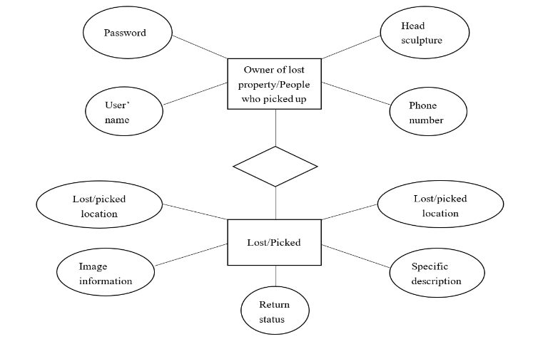

图 2 系统整体E-R图

系统测试

#### 运行测试

功能测试是对失物招领平台的各项功能进行验证，根据功能测试用例，逐项测试，检查平台是否满足设计要求。本文从登录APP开始，逐步测试需求是否完成，确定数据是否一致，是否可以正常接收和返回。例如:用户注册功能是否完善，注册成功后丢失和捡起的信息是否可以发布和共享。其次，测试软件的逻辑，页面转换是否按要求正常完成等。例如，当单击“Publish”时，信息将跳转到显示信息的页面。当信息量较大时，滚动条起作用。最后，测试软件的闪回和系统启动时间以及网络请求时间。下面是注册/登录功能的示例，如表1所示

**表 1 登陆功能测试**

|  |  |  |  |  |  |  |  |
| --- | --- | --- | --- | --- | --- | --- | --- |
| Project name | | Design and Implementation of Campus Lost and Found Platform Based on Map Data | | | | | |
| Test environment | |  |  | Android8.0.0 | |  |  |
| tester | |  |  | Tester | |  |  |
| Test module | |  |  | Registration/login function | | |  |
| Numbering | Scenes | Precondition | Test | Expected results |  | Test Results | Remarks |
|  |  |  | procedure |  |  |  |  |
| 1 | Initial page | Install APP | Click to | Present |  | Present | Unregistered |
|  | display | users | enter APP | registration/login |  | registration/login | users cannot |
|  |  |  |  | interface |  | interface | log in |
| 2 | Account | Install APP | Click to | Show input |  | Show input | The account |
|  | entry | users | enter an | account |  | account | number is 11 |
|  | verification |  | account |  |  |  | mobile phone |
| 3 | Account | Account | Click to | Show account |  | Show account | Enter the |
|  | fault | entered | enter your | verification |  | verification | account ID |
|  | tolerance |  | password | succeeded |  | succeeded | that does not |
|  | verification |  |  |  |  |  | exist X |
| 4 | Password | Account | Click to | Show input |  | Show input | The password |
|  | input | entered | enter your | password |  | password | is 8-13 letters |
|  |  |  | password |  |  |  | plus numbers |
| 5 | System | Account and | Click to | Display |  | Display | Get user |
|  | login | password | Login | homepage |  | homepage | location |
|  |  | have been |  |  |  |  | information |
| 7 | Password | Account and | Click to | Log in system |  | Log in system | Password |
|  | check | password | Login |  |  |  | verification |
|  |  | have been |  |  |  |  | did not |
|  |  | entered |  |  |  |  | successfully |
|  |  |  |  |  |  |  | display the |
|  |  |  |  |  |  |  | password error |

性能测试

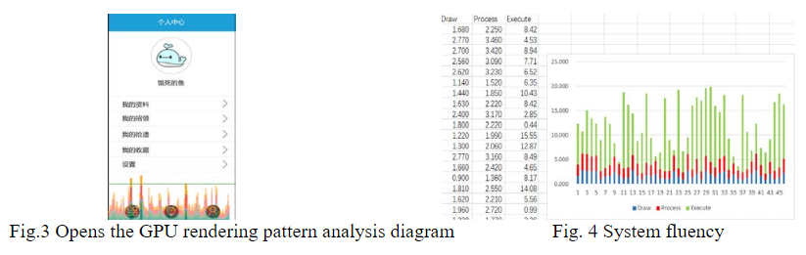

重新启动失物拾得APP应用程序，启动应用程序，相应滑动页面，在命令行下输入对应的指令，找到需要的流利度数据，放入Excel表格中，以表格图表的形式查看流利度，如图4所示。

详细描述

本发明的各种实施例将参照附图进行详细描述，其中类似的参考数字在几个视图中表示类似的部件和组件。参考各种体现并不限制本发明的范围，即仅受本发明所附权利要求的范围的限制。另外，本规范中所述的任何示例都不打算对所述发明进行限制，而只是列出所述发明的许多可能实施例中的一些。除其他外，本发明可体现为甲基苯丙胺或装置。因此，本发明可以采取完全硬件实施例、完全软件实施例或软硬件结合的实施例的形式。因此，以下的详细描述是不能以一种有限的意义来理解的。

在整个规范和权利要求中，下列术语采用与本文明确相关的含义，除非上下文另有明确规定。短语“在本实施例中使用的一个实施例中不一定指同一实施例，尽管它可以。这里使用的“或”是一个包含“或”的操作符，与“和/或”等同，除非上下文另有明确规定。“基于，部分地，基于”、“基于，至少部分地，基于”或“基于”并不是排他性的，除非上下文另有明确规定。此外，在整个规范中，“a”、“an”和“the”的含义包括复数引用。in的意思包括in和on。

简单地说，本发明的某些实施例与失物招领系统和方法有关，包括使有关失物招领的信息能够实时存储。该方法还包括使能调整交互式地图的视场。该方法还包括接收用于搜索丢失对象的搜索输入。该方法还包括根据至少存储的关于找到的对象、搜索输入和交互式地图的视图的信息来执行对丢失对象的搜索。该方法还包括使搜索结果能够覆盖在交互式地图上。

说明性操作环境

图1显示了本发明可实施的环境实施例的一个组成部分。并非所有组件都需要实施本发明，并且可以在不偏离本发明的精神或范围的情况下更改组件的排列和类型。如图1所示，系统100包括局域网(“局域网”)/广域网(“广域网”)-(网络)105、无线网络110、客户端设备101-104、服务设备108、nap服务器107。

可作为客户端设备101-104之一使用的客户端设备的一个实施例在下面的图2中进行了更详细的描述。然而，一般情况下，客户端设备102-104可能包括几乎任何能够通过网络接收和发送消息的移动计算设备，如无线网络110或类似的设备。这类设备包括por table设备，如移动电话、智能手机、dis play寻呼机、射频(RF)设备、红外(IR)设备、个人数字助理(pda)、掌上电脑、笔记本电脑、可穿戴电脑、平板电脑、组合一个或多个前置设备的集成设备等。客户端设备101可能包括几乎所有通常使用有线通信媒介进行连接的计算设备，如个人计算机、多处理器系统、基于微处理器或支持语法的消费电子产品、网络pc等。在一个实施例中，一个或多个客户端设备101-104也可以配置为在有线和/或无线网络上操作。

客户端设备101-104通常在功能和特性方面差异很大。例如，手机可能有一个数字键盘和几行单色LCD播放，只能显示文本。在另一个例子中，一个支持web的客户端设备可能有一个touchsen sitive屏幕、一个手写笔和几行彩色LCD显示，其中文本和图形都可以显示。

支持web的客户端设备可能包括一个浏览器应用程序，它被配置为接收和发送web页面、基于web的消息或类似的内容。可以将浏览器应用程序配置为接收和显示图形、文本、mul timedia或类似的内容，几乎使用任何基于web的lan guage，包括无线应用程序协议消息(wireless application protocol messages, WAP)或类似的内容。在一个实施例中，浏览器应用程序能够使用手持设备标记Language (HDML)、无线标记语言(WML)、WML脚本、JavaScript、标准通用标记语言(SMGL)、超文本标记语言(HTML)、可扩展标记语言(XML)或类似的东西来显示和发送信息。

客户端设备101-104还可以包括至少另一个客户端应用程序，该客户端应用程序被配置为从另一个计算设备接收内容。客户机应用程序可能包括提供和接收文本内容、多媒体信息或类似内容的功能。客户机应用程序可以进一步提供标识自身的信息，包括类型、功能、名称等。在一个实施例中，客户端设备101-104可以通过各种机制中的任何一种唯一地标识自己，包括电话号码、移动标识号码(MIN)、电子序列号(ESN)、移动设备标识符、网络地址或其他标识符。标识符可以在发送到另一个计算设备的消息或类似消息中提供。在一个实施例中，客户端设备101-104可以进一步提供可用于检测客户端设备位置的信息。这些信息可以以消息的形式提供，也可以作为单独的消息发送给另一个计算设备。客户端设备101-104也可以配置为通信消息。例如，通过电子邮件、短消息服务(SMS)、多媒体消息服务(MMS)、即时消息(IM)、internet中继聊天(IRC)、Mardam-Bey的IRC (mIRC)、Jabber或其他类似的计算设备之间的通信。然而，本发明并不局限于这些消息协议，而且几乎可以使用任何其他消息协议。

总结

Android4.4通过重复的测试平台的实际情况及以上各种功能,如用户注册、登录、发布丢失的属性信息,推动丢失的属性信息,测试结果表明,该平台可以顺利运行上述功能和满足设计要求。

在未来将对平台进行维护和优化，进一步提高平台的视觉效果、流畅性和实用性，切实有效地提高失物招赔的概率和用户体验。

随着互联网技术的飞速发展，互联网技术已经渗透到人们生活的各个领域。合理利用互联网技术可以有效提高人们的生活质量。本网络平台致力于互联网在学校失物招领领域的应用。平台成熟后，将进一步向更广阔的领域推广，为更多的人提供优质的失物招领服务。

参考文献

1. 张强，钟勇，周微博。基于六度分离理论的关联规则挖掘算法[J]。计算机应用,2017年,37 (S2): 210 - 213。
2. 匡建波，任玉国，黄晓阳。基于Android平台和百度地图API的旅游助手[J]。科技风，2018(21):89。
3. 谭一云。嵌入式处理器中面向硬件的Java对象模型[J]。微处理器和微系统公司,2018年版。
4. 舒广元,H.C.斯蒂芬•陈，胡锦涛。实现WebGL和HTML5在大分子可视化和现代计算机辅助药物设计中的应用[J]。生物技术趋势,2017,35 (6)。
5. 毛庄。CSS3在web开发中的特点[J]。江西广播电视大学学报，2014(01):92-94。
6. 任盈盈。智能手机UI交互界面人性化设计研究[J]。包装学报,2016,8 (03):83 - 86。
7. Android 8.1预览版新增功能及Android Studio 3.0新增功能[J]。计算机编程技能与维护，2017(21):4。
8. 移动广告市场呈爆炸式增长[J]。证券指南,2014 (44):44-51 . .
9. 苏宇峰。Android APP消息推送行为特征的测量与分析[D]。湖南大学,2017。
10. 吴天龙。分布式异构数据源个性化推荐系统的研究与实现[D]。哈尔滨工业大学，2013年。
11. 赛义德·雷扎·沙哈米里、万·莫赫德·纳西尔·万·卡迪尔、苏海米·易卜拉欣、西蒂·扎顿·穆赫德·哈希姆。软件测试自动化框架[J]。信息与软件技术，2011,53(7)。
12. 李晶晶。基于JDBC的内存数据管理技术研究[D]。华北理工大学，2018。
13. 邵超，万春红。e-r图的详细设计[J]。计算机教育,2015(08年):78 - 81。
14. 张芸。材料辅助管理系统的设计与实现[D]。东北大学,2013。
15. 黄田。Android应用程序运行流畅性GUI测试与分析[D]。中国科学院大学，2016.67

**（2019）弗朗西斯学术出版社，英国 DOI: 10.25236/ciais.2019.013**